**Complex Numbers and the Imaginary Unit**

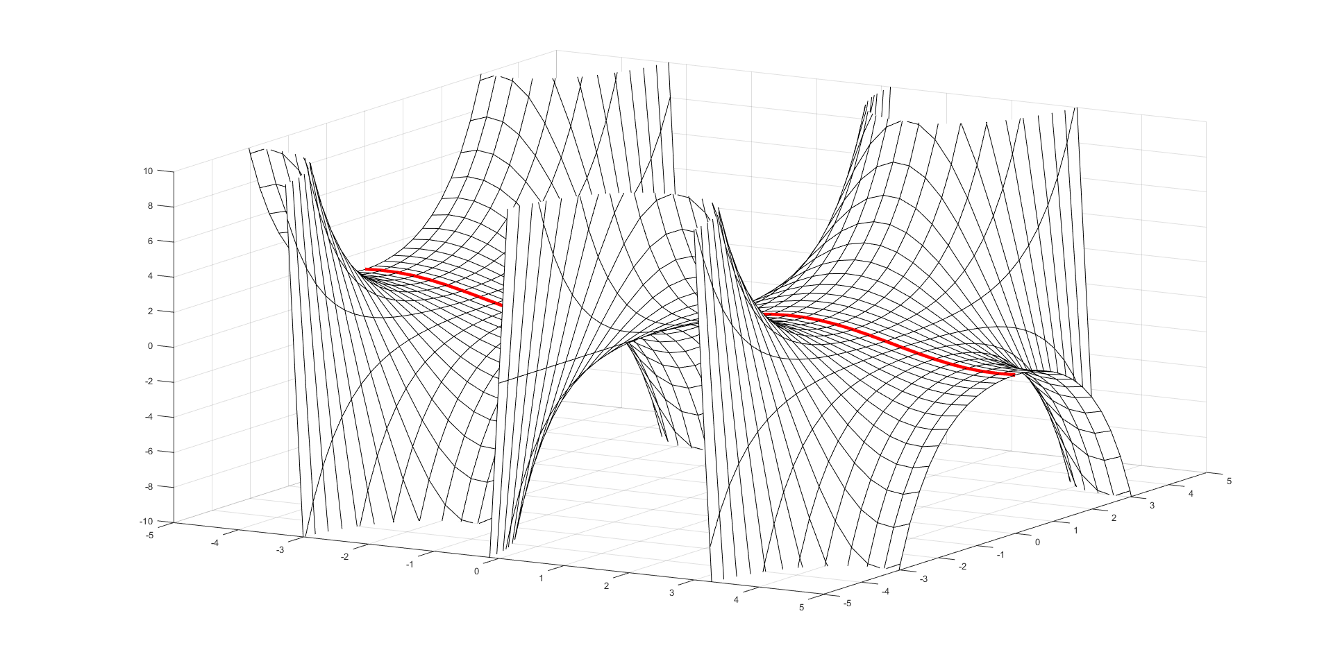Shaun Burriss

2019-05-02

Mathematics – Pre-Calculus / Calculus

**Table of Contents**

Unit Plan Overview …3

Letter to Parents …9

Lesson 1 …11

Lesson 2 …14

Lesson 3 …17

Lesson 4 …20

Lesson 5 …25

Reading 1 (by Michael Hutchings) …27

Reading 2 (by Katharine Ott) …54

Proof Project …57

**Page break**

**Unit Plan Overview**

Unit Title: Complex Numbers and the Imaginary Unit

Subject/Class: Mathematics (Honors/Advanced Pre-Calculus)

Grade level: 11/12

**Introduction:**

The purpose of this unit is to introduce students to the idea of a complex number, in the forms a+bi and others, and the applications of these numbers in theory and practical application. Graphical representation will be emphasized to help students visually identify complex numbers and functions of complex numbers. Problem solving with complex numbers is important for later calculus and advanced college mathematics, as well as in engineering fields (particularly physics, electromagnetics, photonics, and electrical engineering). For foundational or especially advanced concepts, the teacher will provide more direct instruction to lay the groundwork or help students figure out concepts it would take too long to discover on their own. For the material in between, the teacher will take on more of a facilitator role; providing materials, examples, readings, and opportunities to explore these concepts and demonstrate skills.

**MI Framework Standards:**

N-CN:

1. Perform arithmetic with complex numbers
   1. Know there is a complex number i such that i^2 = –1, and every complex number has the form a + bi with a and b real.
   2. Use the relation i^2 = –1 and the commutative, associative, and distributive properties to add, subtract, and multiply complex numbers.
   3. (+) Find the conjugate of a complex number; use conjugates to find moduli and quotients of complex numbers.
2. Represent complex numbers and their operations on the complex plane.
   1. (+) Represent complex numbers on the complex plane in rectangular and polar form (including real and imaginary numbers), and explain why the rectangular and polar forms of a given complex number represent the same number.
   2. (+) Represent addition, subtraction, multiplication, and conjugation of complex numbers geometrically on the complex plane; use properties of this representation for computation. For example, (–1 + √3i)^3 =8 because (–1 + √3 i) has modulus 2 and argument 120°.
   3. (+) Calculate the distance between numbers in the complex plane as the modulus of the difference, and the midpoint of a segment as the average of the numbers at its endpoints.
3. Use complex numbers in polynomial identities and equations.
   1. Solve quadratic equations with real coefficients that have complex solutions.
   2. (+) Extend polynomial identities to the complex numbers. For example, rewrite x^2+4 as (x +2i)(x –2i).
   3. (+) Know the Fundamental Theorem of Algebra; show that it is true for quadratic polynomials.

F-IF:

1. Analyze functions using different representations
   1. Graph functions expressed symbolically and show key features of the graph, by hand in simple cases and using technology for more complicated cases.
2. Write a function defined by an expression in different but equivalent forms to reveal and explain different properties of the function.

**Unit Objectives:**

Upon completion of the unit, students will be able to...

1. Define the complex unit *i* and how it relates to the real numbers.
2. Perform arithmetic with complex numbers.
3. Recognize complex numbers in rectangular and polar forms and illustrate them graphically.
4. Extend the real number system to the complex numbers - identify which properties still hold and which require tweaking.
5. Manipulate expressions containing *i* to convert between various rectangular, polar, and other forms.
6. Determine which form is most appropriate for a particular problem and convert expressions into that form.
7. Find the conjugate of a complex number and use it to help solve equations and convert forms.
8. Find the modulus (or the magnitude) and the quotient (or the argument) of a complex number, and convert from a magnitude and argument back to a complex number.
9. Describe the correlation between vectors and complex numbers on the z-plane.
10. Represent complex number arithmetic by vector combinations on the complex plane and convert between the two forms.
11. Calculate the magnitude and argument of a complex number graphically.
12. Solve polynomial equations with real coefficients that have complex solutions.
13. Explain the Fundamental Theorem of Algebra and apply it to polynomial equations to find complex solutions.
14. Show which which algebraic identities apply to complex numbers and which require tweaking.
15. Apply complex numbers to real world problems.

(Extra objectives with advanced topics. These may be dropped or shortened depending on how the previous objectives go and how much time is remaining.)

1. Understand functions in complex variables and how to convert between the forms f(z) and f(x,y) using the identity z=x+iy.
2. Solve basic polynomial equations with complex variables graphically and algebraically.
3. Use Euler’s identities to convert expressions with complex variables between trigonometric, exponential, and rectangular forms.
4. Derive and prove various useful identities from real-number mathematics using complex numbers.
5. Graph the real part, imaginary part, and phase portrait of complex variable functions and understand what each graph represents as well as its limitations.

**Big Ideas:**

Complex numbers are an extension of the real numbers, which in themselves are an extension of the rationals and so on all the way down to the natural numbers (which some may argue are an extension of 1). This number system stems from the answer to the simple question: what is $\sqrt{-1}$? Mathematicians answered that question with a letter, *i*, and as it turns out, complex numbers can be incredibly useful in the real numbers as well as many fields of math, physics, and engineering.

Real valued functions can be extended to the complex plane, which allows the computation of previously impossible integrals and other quantities. Functions that blow up to positive or negative infinity on the real numberline are no longer a problem in the complex realm; just integrate *around* the singularity! Complex numbers are used to calculate graphical effects, in electrical engineering for even basic computations, and in other fields through their ability to take impossible problems in the reals and convert them to easily solvable – or at least approximatable – problems.

In advanced topics, there is a whole field of mathematics dealing with complex numbers and analysis. What happens if the variable in these equations is in itself a complex number? In this unit, we won’t get to anything beyond the basics of working with complex variables, both graphically and through use of Euler’s identities.

Background research and student prior knowledge/misconceptions:

Students often have trouble with the graphical representation - requires more thinking, less algebra. Algebra skills are very important for manipulating complex numbers and *i* is often dropped or forgotten about - watch out, be careful. Placing a letter in front of a coefficient can throw students - work on understanding letters can go wherever (Ahmad, 2014).

Work on ability to apply knowledge to novel problems, rather than just working examples and changing them slightly for the test. Students often have trouble thinking creatively and applying their new skills (Selden, 1994).

Need background in algebra, graphing, trigonometry, and vectors (nice to have, not required).

**Literacy-based Instructional Strategies:**

* Think-aloud working through problems/notation for modeling correct behavior.
* Related: rereading – focus on overall idea, then problem statement, then details, etc.
* Related: retelling / summarizing – take complex thing, re-explain in own words.
* Word parts – roots, suffixes, prefixes, related notation, etc.
* Practice – have students work with academic language, write their own problems, proofs, papers, grade on AL as well as correctness.
* Exposure – use the proper terminology, don’t just skip over it.
* Questioning – give some time for kids to think. 7-ish seconds?
* Discussions – not ping pong! Allow students to guide, nudge back to topic if needed.

**Literacy Focus:**

The major literacy focus in this unit is writing a convincing, professional, academic proof of a fairly complex phenomenon. This sort of writing is the primary academic communication in higher mathematics, with textbooks, academic papers, and even classes often revolving somewhat or significantly around proofs. Students will need to learn how to write clearly and concisely without sacrificing accuracy, write at a level appropriate to their audience, and work within proper notation and conventions for proof writing.

Much of proof writing involves working with inquiry and academic thinking, then writing it out in academic language. Students will likely come without much of the language needed to write a solid proof, so a review of the fundamentals of notation and language is included in several readings in several lessons. As Zwiers says in his book *Building Academic Language*, many teachers are tempted to “resolve” this issue of students not knowing the correct academic language by just not using it and substituting colloquial terms instead. While this can be helpful to start with, it will eventually do students a disservice when they move on to higher levels where they will be expected to know the language – I intend to ensure students are exposed to and utilize mathematical language in class. However, connecting this language to colloquial terms is still a useful strategy and helps students make connections and understand these abstract concepts. As for the inquiry side of the coin, students are encouraged to come up with and solve their own problem in the proof project. Working through the steps of observing a phenomenon, figuring out how it works, then being able to show why it works is a very authentic practice of academic thinking.

Another major part of working to prove theorems is working with one’s peers, particularly in a discussion setting. Many of the lessons included in this unit will implement discussion in one form or another, primarily in smaller groups that can then share to the larger group if needed. One of the big problems with discussion is initiating it, and a lot of that has to do with student nervousness in a large group. I’ve found that it often works better to start students off in smaller groups to discuss the problem, then have groups compare results afterwards. They’re already warmed up and thinking about the problem from their group discussion, and speaking with the backing of their group helps reduce nervousness.

**Materials and resources:**

* Whiteboard and various colors of markers.
* Desired: portable whiteboards, if possible with grid lines pre-printed. Otherwise, graph paper.
* Computer with projector and modeling / graphing software (ie MATLAB, Mathematica, etc). Can probably get away without this but would vastly improve especially advanced topics.
* Worksheets / example problems (self-made if time allows).

**Instructional Sequence**

Lesson 1: The complex number system

Introduction to the unit *i*, go over the complex number system and how it differs from the reals - what operations are now closed, etc. Introduce the form a+bi. Work with examples, operations. +, -, *, /, magnitude, and conjugate. Convert from various expressions into a+bi form. Much of this will be active lecture, where the students are involved in figuring out the concepts by the teacher asking questions from the board.

Lesson 2: Representing complex numbers graphically and algebraically

Introduce r(cos(t)+isin(t)) form and the z-plane. Graph various complex numbers, demonstrate the operations +, -, *, / by using vector mathematics. Convert between the two forms and from various other expressions to either form. Find magnitude and argument of a complex number graphically and via polar form. Find which form is more helpful in various problems. The introduction to the polar form will again be mostly active lecture, but to determine the precise formulas to use, students will work in groups as an introduction to proofs.

Lesson 3: Polynomial equations with complex roots

Start with basic polynomials (ie x^2 + 4 = 0) and move to more complicated tasks. Work with factoring, completing the square, the quadratic equation, and other tools for solving equations. Understand the Fundamental Theorem of Algebra and how there will always be n solutions for an equation where n is the highest exponent. As this is a foundational concept, active lecture will be utilized primarily.

Lesson 4: Complex polynomial equations

Work with polynomial equations primarily, but additionally other types of expressions, to find roots and use other tools for solving equations much the same as in lesson 3. Understand the intricacies of the Fundamental Theorem of Algebra, including conjugate pairs and how to determine how many real or complex roots are possible from a given equation. Introduce the proof project and allow time to work. As this is a lesson that builds on previous lessons, students will work on their own to derive formulas and create convincing proofs of theorems.

Lesson 5: Advanced topic: Complex variables

Introduce z=x+iy and basic expressions of the form z^n = 1 or something similar. Work to solve these graphically. Derive Euler’s Identities (ie $e^{iπ}+1=0$ and the rest) and show how to convert between all forms: rectangular, polar, and exponential (r*e^it). Determine which form is most appropriate for what problem and work on applying these forms in real world problems. Due to the high complexity of the topic, this lesson will be primarily active lecture.

Lessons 6+: Advanced topics: complex variables (will not be included in this lesson plan unless time permits - as such, will not be outlined).

**Assessment plan:**

Diagnostic/Formative:

Pretest before first lesson - maybe given at end of last unit. Basic stuff - more along the RUA end of Bloom’s tax - review to see what students already know and if there’s anything to skip.

Entrance warm ups daily - short problem related to the topic to be covered, something students should be able to figure out and then use as a springboard for the day’s content.

Some homework for each lesson - short, maybe 5-10 problems, aimed mostly at taking concepts in class and elaborating on them in a more time-free environment.

Discuss homework at beginning of each class - any hard ones, questions, issues?

Questions, examples during class.

Summative:

Unit test at the end - mostly freeform, covering all material in the unit and tying back to previous units on polynomials, roots, etc. This will help cover the content standards part of the assessment, allowing students to demonstrate their understanding of the mathematical material we covered.

Project – Proof project. Find an interesting pattern or rule in complex numbers, determine why it works the way it does, write up an academic proof, and present. This will help cover the academic literacy portion of the unit – explaining and convincing others of particular mathematical theorems. This is also far more authentic learning, as real mathematicians spend a lot of time working with proofs.