Name _____________________________ Date ____________

Directions: Convert each complex number to the form $r(\cos\left(θ\right)+i\sin\left(θ\right))$

1) $1+i√3$ | 2) $4-3i$
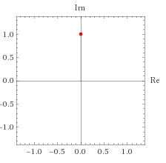  3) | 4) $\sin\left(\frac{π}{3}\right)+i\cos{(\frac{π}{3})}$

Challenge Problems
Directions: These are optional bonus problems you may attempt if you desire.

C1) Suppose you have the function $z=t(\cos{t}+i\sin{t})$. What would this function look like on the complex plane as t goes to infinity? What if t goes to negative infinity? Do these two graphs (as t goes to positive or negative infinity) intersect, and if so, where?
Hint: t is a purely real variable. Feel free to use the back of the worksheet to draw a graph.

